Y motor assembly

Vitamins
4 M4 cap screw x 16mm  1 NEMA17 x 47mm stepper motor  4 Nyloc nut M4  4 M3 cap screw x 10mm | 1 GT2 pulley 20 teeth  4 Washer M3 x 7mm x 0.5mm  4 Washer M4 x 9mm x 0.8mm  4 Star washer M3 x 0.5mm

Printed parts
1 y_motor_bracket.stl
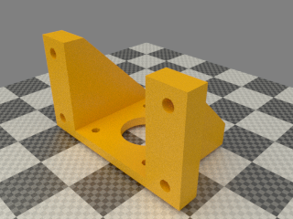

Assembly
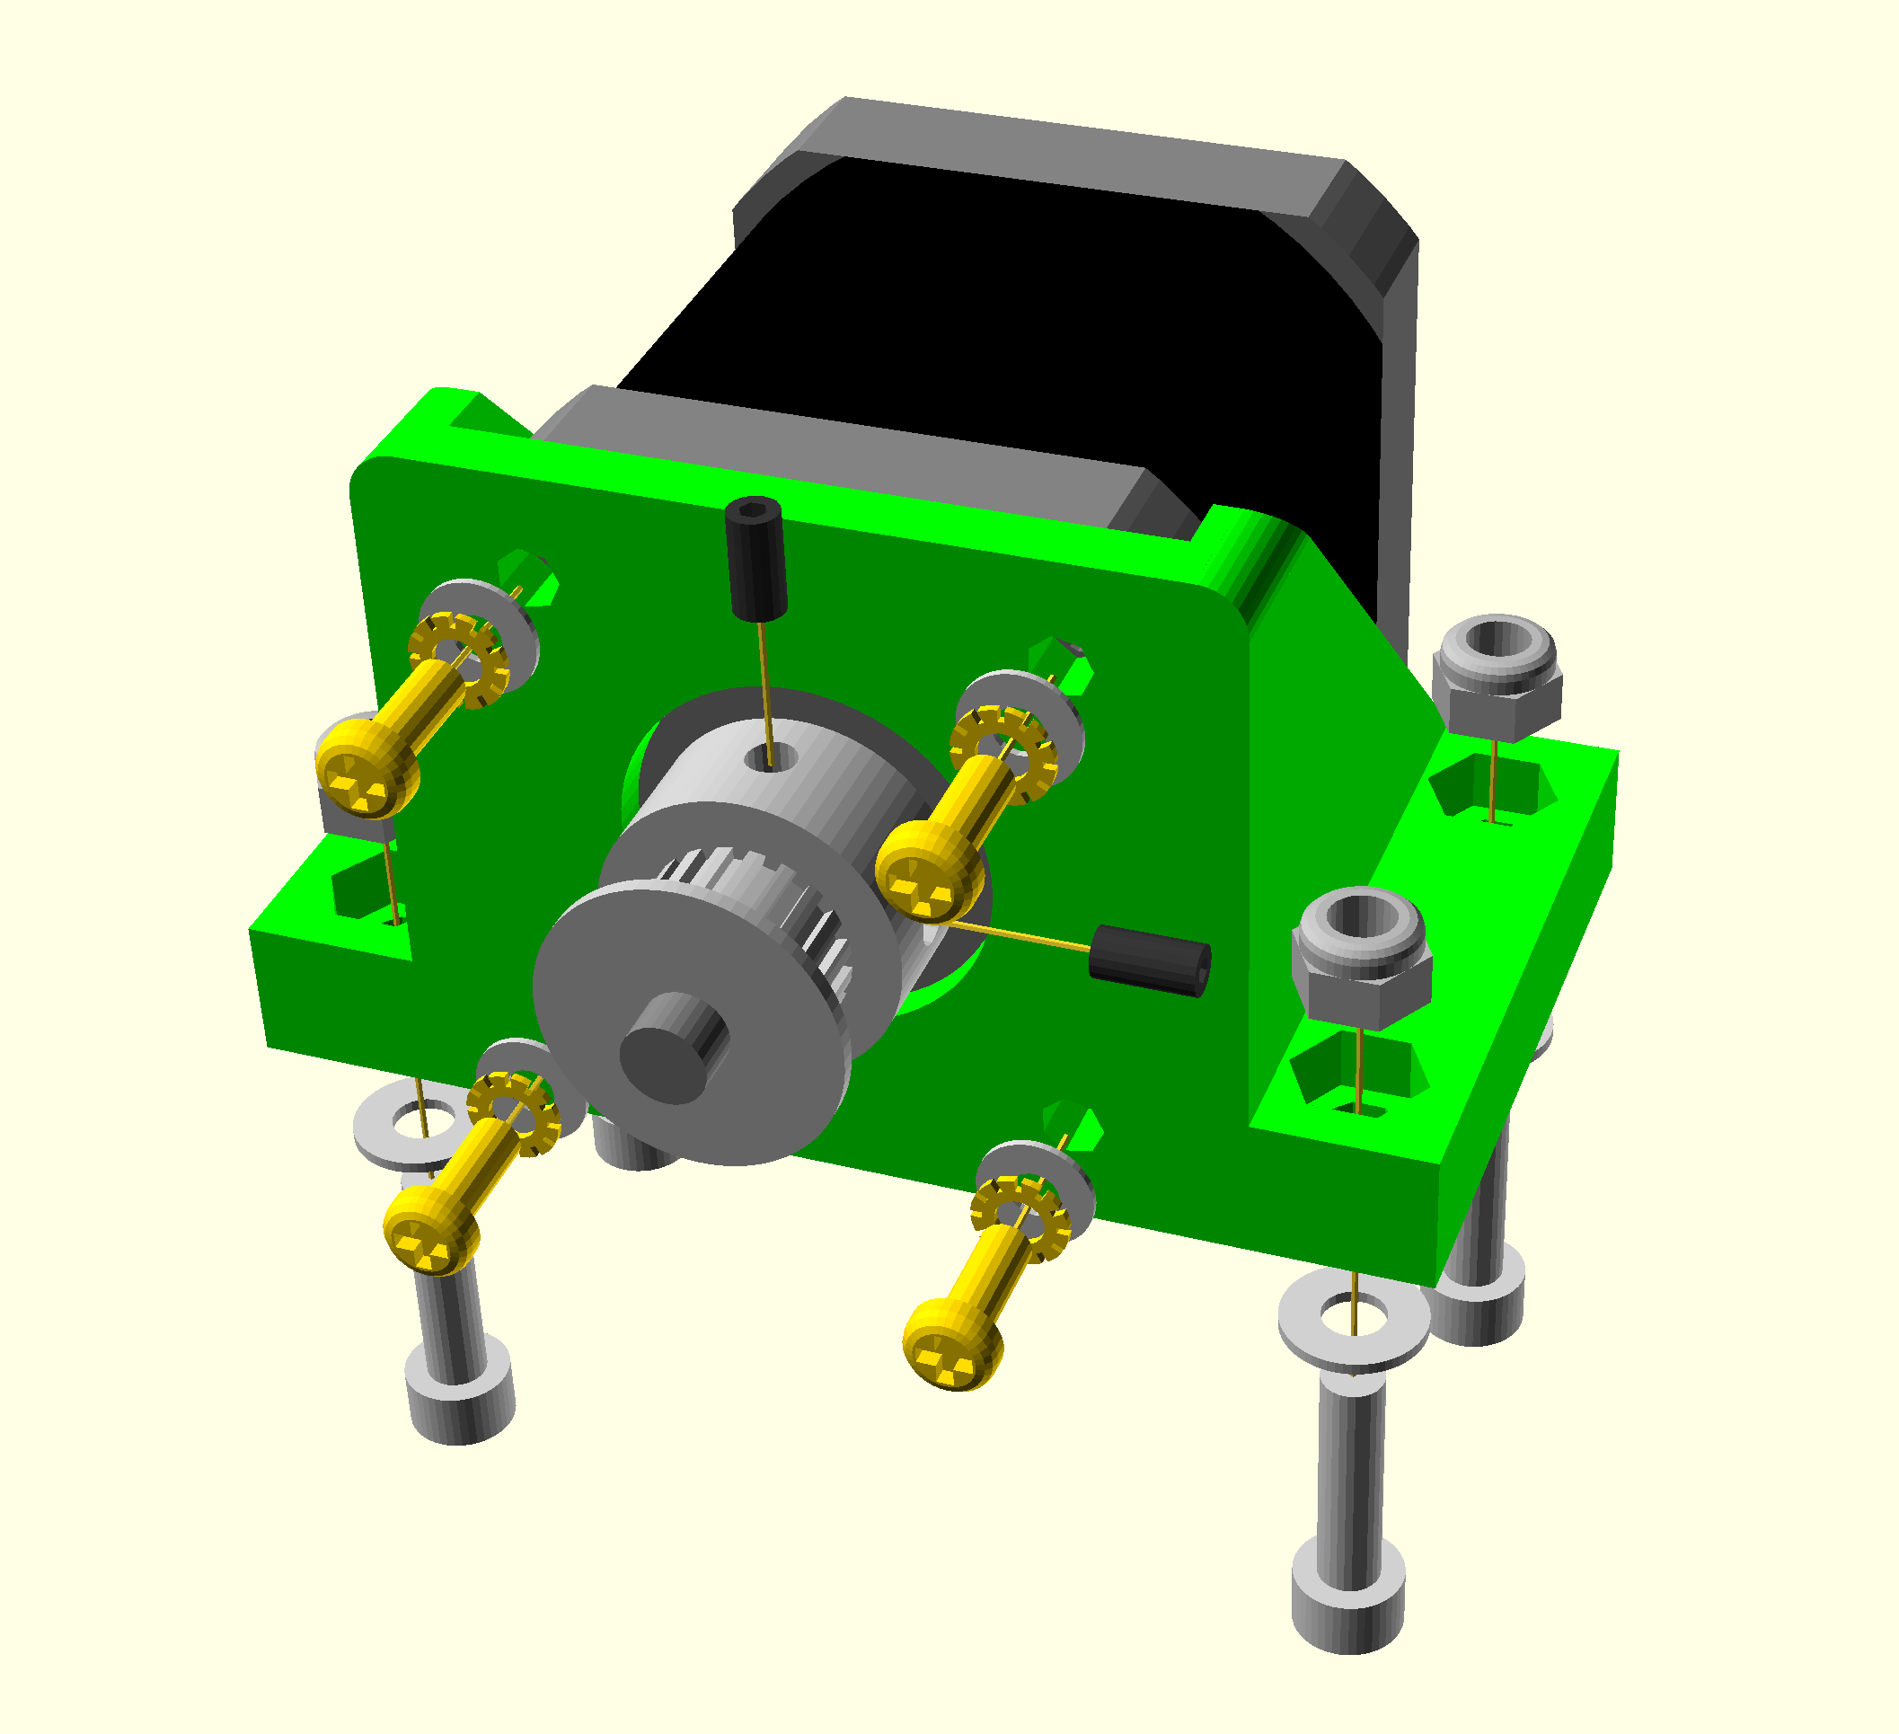
Assemble as shown above with the motor shaft protruding 3mm from the pulley. The wires should be twisted in pairs (as described for the Z motors) and exit up or sideways.

